Duncan Street Primary Care Centre

BLAKENALL, Wolverhampton WV2 3AN

Tel: 01902 459076

|  |  |
| --- | --- |
| **Option 1** | Appointments queries, ordering sicknotes |
| **Option 2** | prescription queries after 11.00am |
| **Option 3** | Medical letters and insurance report enquiries after 9.30am |
| **Option 4** | Referral queries after 9.00 am |
| **Option 5** | General enquiries, and blood test results after 11.00am |
|  |  |

Email: [bcicb.duncanstreet@nhs.net](mailto:bcicb.duncanstreet@nhs.net) (incoming only)

[www.duncanstreetprimarycarecentre.co.uk](http://www.duncanstreetprimarycarecentre.co.uk)

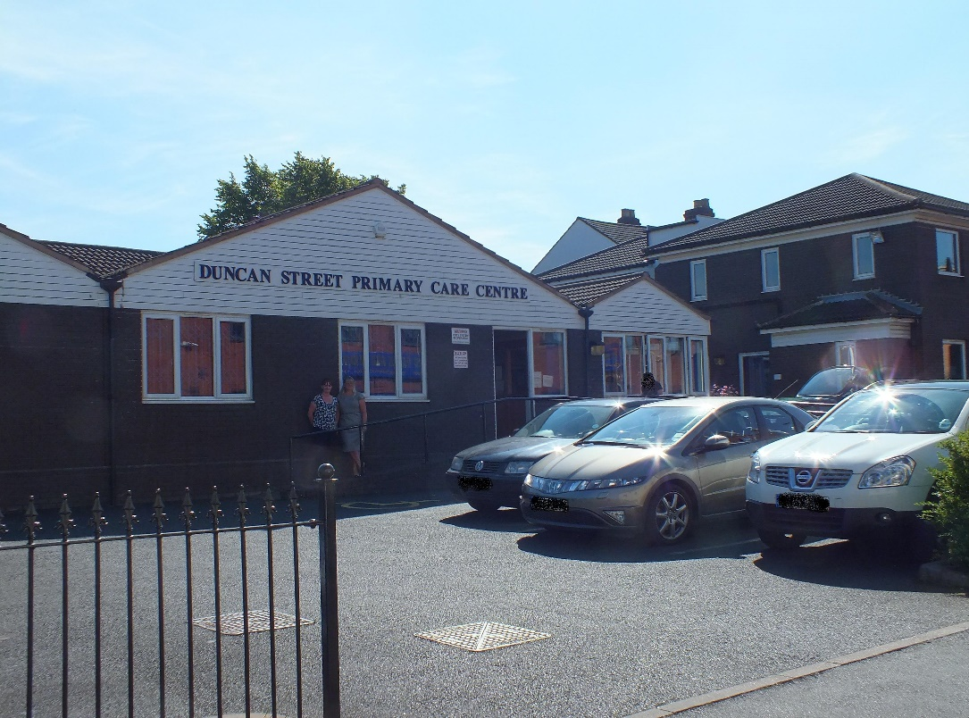

**Updated: March 2025**

**Surgery Opening Hours**

*Opening Times*

Monday 8.00am-6.30pm

Tuesday 8.00am-6.30pm

Wednesday 8.00am-8.00pm

Booked appointments only after 6.00pm on late night opening.

Thursday 8.00am-6.30pm

Friday 8.00am-6.30pm

Please note: Surgery doors open at 8.30am each morning and close at 6.00pm each evening, the telephone lines will be active from 8.00am – 6.00pm.

During the lunchtime period the surgery doors are closed between 1.00pm – 2.00pm each day.

When the surgery is closed, the telephone system should automatically divert calls to 111, the emergency out of hours GP service.

**Welcome**

Welcome to Duncan Street Primary Care Centre. The information in this booklet should help you get the most from your Practice. Our aim is always to provide you with an excellent service. All members of the team: clinical and non-clinical staff are committed to providing this for you.

The clinical team consists of doctors, nurse practitioner and practice nurses. Other health care professionals visit the Practice to see and treat patients.

There are a large number of doctors at the surgery, including doctors training to be GPs.

There are facilities for disabled patients, including specific parking spaces, a lift and ramp access for wheelchairs. A wheelchair is available for patients who have difficulty walking from the waiting room to the consulting rooms. We welcome guide dogs anywhere in the building.

The clinical team is fully supported by a team including receptionists, administrators, secretary, senior receptionist and practice manager.

If you have any questions or concerns, please ask to speak to the Senior Receptionist or the Practice Manager.

**Doctors and Qualifications**

Dr Saumya Agarwal (M) Senior GP Partner MBBcH, MRCGP

Dr Shweta Aggarwal (F) MBBS, MRCGP

Dr Sophia Nazir (F) MMBS, MRCGP

Dr Baljinder Sangha (F) MBBS, MRCGP

Dr Reneka Farmah (F) MuDr and MRCGP

Dr Munisha Kahlan (F) MB ChB

**Accountable GP** for all newly registered patients and aged 75 and over**.** – Dr Saumya Agarwal

**GP Partners** – Partnership - Dr Saumya Agarwal & Dr Shweta Aggarwal – Duncan Street Primary Care Centre, WV2 3AN

The surgery also has GP registrars and Foundation Year Two doctors. The GPRs are fully qualified doctors who are training to be GPs. The FY2 doctors are in their second year of qualification, gaining experience in general practice before specialising.

All doctors in training are always supervised, and if they are not entirely sure what care or prescription is required, they will seek advice.

**The Practice Manager**

The Practice Manager is responsible for the overall management of the Practice. They will be pleased to discuss any non-medical problems with you and welcomes any suggestions you may have for improving the service provided.

**The Reception Team**

The receptionists are trained to help and guide you. All information they receive will be treated in the strictest confidence. Please do not blame the receptionist if you are unhappy with the service you receive. If there is a problem, please email in and follow the complaints process.

**Administration staff/Secretary**

The Administration Team are responsible for arranging various clinics and registration of new patients and any information or documentation required for outside agencies.

The secretary provides administration support for the Practice dealing with all GP referrals.

**The Nursing Team**

They see patients with minor injuries, minor illnesses, run child vaccination clinics, provide cervical smears, contraceptive injections and offer reviews for patients with long term conditions such as asthma, COPD and diabetes.

**Nursing Team**

**Nurse Practitioner:**

Ros Rawlinson - RGN DIPDN Diabetic Diploma, BSc (Hons) Healthcare Practitioner

**Practice Nurses:**

Lisa Bromley

Registered nurse Level 2 1989

Registered Nurse level 1 2002

Kirsty Darley

Reg Nurse / Independent Supplementary Prescriber, Diploma in Diabetes, Asthma and COPD

# Out of Hours Arrangements

If you have a medical problem after 6.30pm in the evening and before 8.00am in the morning which cannot wait until the surgery is open, there is an out of hours GP emergency service. This can be accessed by calling the surgery number, where you will be diverted to the appropriate service. Otherwise the out of hours services can be contacted by calling 111. Please only use the 999 service for medical emergencies. During all other hours use the practice telephone number shown on the front cover of this leaflet.

We take part in providing extended access for patients across out Primary Care Home network. We have Information Governance in place to enable shared IT via our systems. These appointments can be accessed by contacting the reception team who can book these appointments for routine and urgent appointments.

BC ICB (Black Country Intergrated Care Board) are responsible for commissioning out of hours.

**Other Sources of Advice**

*NHS 111 Number*

111 are available at all times for medical advice. Please call 111

*Community Pharmacies*

The surgery takes part in a minor ailments scheme. If you know what is wrong, e.g. headlice, but do not pay for prescriptions, you can go to the pharmacy and ask for a minor ailment form. Receptionist may also triage for the pharmacy first scheme.

*Walk in Centres*

There are two Walk-in Centres in Wolverhampton. Wolverhampton Walk-in Centre at the Phoenix Centre is led by nurse practitioners, who can prescribe, or you can attend the Urgent Care Services at New Cross Hospital. Patients do not have to register at these services in order to be seen.

**Interpreter Services**

Interpreters can be booked, including sign language giving us as much notice as possible. The surgery routinely uses Language Line telephone interpreting.

If you are attending on appointment and may require an interpreter, please check with the surgery beforehand, so this can be arranged.

**How to Register**

**Registering as a new patient**

If you wish to register at the practice, you must attend the surgery in person with Photo ID and proof of current address, if children are registering they must also attend.

Waiting list for registrations at present is up to six weeks. If form is not completed in full there is likely to be a further delay.

* A registration form (PRF1) can be collected from the reception
* Registering online – go onto the surgery website and click ‘Click here to register as a new patient link’.
* All patients must attend personally to hand in completed forms.
* We only except completed PRF1 forms and ID's after 10.00 am Monday to Friday.
* If you have a current NHS number please make sure you enter this on the form.  You can find your NHS number on this link, <https://www.nhs.uk/nhs-services/online-services/find-nhs-number/>.
* Your details will then be entered onto our system and once NHS England have approved your details, the practice will send you a text for you to book a New Patient Check appointment.
* You MUST attend this appointment to complete your registration.
* If you do not book or attend your New Patient Check appointment you may be unable to see a Doctor when you need to.
* IF YOU REGISTER ELSEWHERE BEFORE RECEIVING A TEXT FROM US PLEASE LET US KNOW SO WE CAN CANCEL YOUR REGISTRATION.

**Practice Boundary Area**

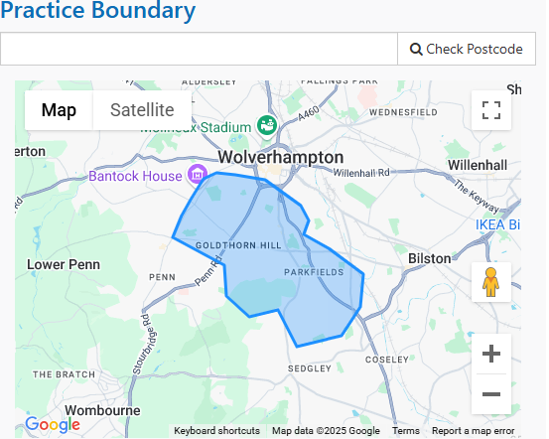

**Ordering Repeat Prescriptions**

1. E-mail: [bcicb.duncanstreet@nhs.net](mailto:bcicb.duncanstreet@nhs.net) (incoming only)

1. Hand into receptionist at front desk.
2. Register for the NHS App to gain access to your records and request prescription through this system. (ask reception about registering for online access).
3. By post, enclosing a stamped addressed envelope if you wish us

to post your prescription back – otherwise you will need to collect it for the practice.

1. Ask your nominated pharmacy to order on your behalf

Please use the other half of your prescription to request items. If you do not have this, complete one of the prescription request forms which are available from reception. You need to allow 72 hours for your prescription to be prepared. Prescriptions can be collected during normal surgery hours.

We now participate in (EPS) Electronic Prescription Service. Please visit the EPS website <http://systems.hscic.gov.uk/eps> or you can speak to the pharmacy for further information.

Certain medications cannot ordinarily be ordered on repeat as reviews are needed. Please enquire at reception or during a consultation to find out whether a medication can be ordered.

**Test Results**

In the interests of confidentiality your results will only be given to **you**. You will be asked for information to identify yourself. Parents or guardians of a child under the age of 16 are able to telephone for results. Please phone for test results after 12.00pm if possible as the surgery phone lines are very busy in the morning.

The Surgery has a height, weight and BP machine for you to use, the readings are automatically recorded in your medical notes.

**Access to a GP or Healthcare Professional**

Routine appointments can be booked in advance. Appointments are available if you ring between 8.00am and 11am you can book an appointment for the same day. After 11.00am appointments may not be available for the same day. We have emergency appointments allocated by the Doctor on call every day. **Please note: We do not allow patients to walk in and book an appointment at the front reception desk.**

**Home Visits**

If you feel you require a visit (for housebound patients only), you need to telephone before 10.30am and give details of your illness. A doctor may call to you back to assess the urgency of your request.

Chronic disease checks for the housebound can be arranged. Patients are contacted by the surgery to arrange reviews and if you are housebound, please contact the surgery so a check-up can be arranged.

**Carer**

Our carer lead is Sister Darley. If you look after someone or someone looks after you, please complete a carer form. The practice also has a Carer Notice Board which holds various helpful information

**Equal Access Measures**

There are ramps to the main entrance to the surgery, enabling access for wheelchair users and those with poor mobility. There are disabled parking spaces.

There is a lift suitable for wheelchair users installed in the surgery for those with appointments upstairs. If you have any difficulty with stairs, please inform the clinician calling you and the lift will be used or if you require any assistance please ask at the reception desk. The surgery has a wheelchair available for patients to use if required.

We have a portable hearing loop in the practice if you wish to use it. Please ask a receptionist.

**Non-NHS Examinations**

If you need to have a private medical, e.g. for pre-employment, HGV, taxi driving, an appointment can be arranged. Fees will be charged according to BMA guidelines. Please contact a member of the Admin team for further advice.

**Rights and Responsibilities of Patients**

The practice endeavours to provide an excellent service to all its patients. However, it is important for patients to understand our procedures to enable the surgery to run smoothly. While this surgery will do its best to meet the needs of patients, we will not accept violent or aggressive behaviour or verbal abuse towards our staff. The surgery reserves the right to prosecute offenders.

**ZERO TOLERANCE**

We strongly support the NHS policy on zero tolerance. Anyone attending the surgery who abuses the GPs, staff or other patients be it verbally, physically or in any threatening manner whatsoever, will risk removal from the practice list. In extreme cases we may summon the police to remove offenders from the practice premises.

**Accessible Information Standard**

If you or someone you know has a communication need or require information given in a specialist format, please ask for a form from reception to detail your communication and information preferences

**Access to Medical Records**

All patients are able to view their records via on-line patient Emis access, you will need to register for this service, please ask reception for details.

**Patient Participation Group**

The Practice have always valued the views of their patients and to explore ways of improving communications, enlist views about services and how these can be developed, the practice has a Patient Participation Group. The Group gives feedback on the range and quality of services and on what can be improved and they meet quarterly. If you would like to join them please contact the Practice Manager. There is a Notice Board in the waiting room for latest information.

**Confidentiality and Information**

**How do we maintain the confidentiality of your records?**

We are committed to protecting your privacy and will only use information collected lawfully in accordance with:

* Data Protection Act 2018
* The General Data Protection Regulations 2016
* Human Rights Act 1998
* Common Law Duty of Confidentiality
* Health and Social Care Act 2012
* NHS Codes of Confidentiality, Information Security and Records Management
* Information: To Share or Not to Share Review

Every member of staff who works for an NHS organisation has a legal obligation to keep information about you confidential.

We will only ever use or pass on information about you if others involved in your care have a genuine need for it. We will not disclose your information to any third party without your permission unless there are exceptional circumstances (i.e. life or death situations), where the law requires information to be passed on and / or in accordance with the information sharing principle following Dame Fiona Caldicott’s information sharing review (Information to share or not to share) where “The duty to share information can be as important as the duty to protect patient confidentiality.” This means that health and social care professionals should have the confidence to share information in the best interests of their patients within the framework set out by the Caldicott principles.

Our practice policy is to respect the privacy of our patients, their families and our staff and to maintain compliance with the General Data Protection Regulations (GDPR) and all UK specific Data Protection Requirements. Our policy is to ensure all personal data related to our patients will be protected.

All employees and sub-contractors engaged by our practice are asked to sign a confidentiality agreement. The practice will, if required, sign a separate confidentiality agreement if the client deems it necessary. If a sub-contractor acts as a data processor for Duncan Street Primary Care Centre an appropriate contract (art 24-28) will be established for the processing of your information.

In Certain circumstances you may have the right to withdraw your consent to the processing of data. Please contact the Data Protection Officer in writing if you wish to withdraw your consent. If some circumstances we may need to store your data after your consent has been withdrawn to comply with a legislative requirement.

Some of this information will be held centrally and used for statistical purposes. Where we do this, we take strict measures to ensure that individual patients cannot be identified. Sometimes your information may be requested to be used for research purposes – the surgery will always gain your consent before releasing the information for this purpose in an identifiable format. In some circumstances you can Opt-out of the surgery sharing any of your information for research purposes

**Comments, Suggestions and Complaints**

In the first instance, please speak to one of the receptionists who will endeavour to offer an explanation or solution to your question immediately. If you wish to speak to someone away from the reception area, make this known to the receptionist. If you are still unhappy and do not feel your complaint has been answered or dealt with, speak to the Practice Manager, or leave a message with contact details and they will contact you. If you feel it necessary to put something in writing, please address your letter to the Practice Manager. You should receive acknowledgement of your complaint within three working days. You can contact the local Advocacy Service 01902 572399 or e-mail info@healthwatchwolverhampton.co.uk you can obtain a copy of the complaint’s procedure and comments forms from the reception desk. We continually strive to improve the services here for your benefit and we welcome all your comments – good or bad. You may email [bcicb.duncanstreet@.nhs.net](mailto:bcicb.duncanstreet@.nhs.net) or contact: **Time2Talk** Telephone [0300 0120 281](tel:0300%200120%20281) and select Option 4

Email: [bcicb.time2talk@nhs.net](mailto:bcicb.time2talk@nhs.net)

Address: Time2Talk, NHS Black Country Integrated Care Board (ICB) Civic Centre, St Peter’s Square, Wolverhampton, WV1 1SH

**NHS Choices**

The practice is registered on the website and comments and feedback can be given to the practice. The practice can also respond to your comments directly and answer queries in this manner.

The staff who work here are part of a team. This publication has been designed to enable you to get the best from your practice.

With your consent we would also like to use your information

with regard to your name, contact details and email address to inform you of services that may benefit you, with your consent only. There may be occasions where authorised research facilities would like you to take part on innovations, research, improving services or identifying trends.

At any stage where we would like to use your data for anything other than the specified purposes and where there is no lawful requirement for us to share or process your data, we will ensure that you have the ability to consent and opt out prior to any data processing taking place.  
This information is not shared with third parties or used for any marketing and you can unsubscribe at any time via phone, email or by informing the practice DPO as below