NHS Choices

The practice is registered on the website and comments and feedback can be given to the practice. The practice can also respond to your comments directly and answer queries in this manner.

The staff who work here are part of a team. This publication has been designed to enable you to get the best from your practice.

With your consent we would also like to use your information
with regard to your name, contact details and email address to inform you of services that may benefit you, with your consent only. There may be occasions where authorised research facilities would like you to take part on innovations, research, improving services or identifying trends.
At any stage where we would like to use your data for anything other than the specified purposes and where there is no lawful requirement for us to share or process your data, we will ensure that you have the ability to consent and opt out prior to any data processing taking place.
This information is not shared with third parties or used for any marketing and you can unsubscribe at any time via phone, email or by informing the practice DPO as below.

15

Duncan Street Primary Care Centre
BLAKENALL, Wolverhampton WV2 3AN

Tel: 01902 459076

Option 1 | Appointments queries, ordering sicknotes
Option 2 | prescription queries after 11.00am
Option 3 | Medical letters and insurance report enquires after 9.00am
Option 4 | Referral queries after 9.00 am
Option 5 | General enquiries, and blood test results after 11.00am
Email: bcicb.duncanstreet@nhs.net (incoming only)

www.duncanstreetprimarycarecentre.co.uk

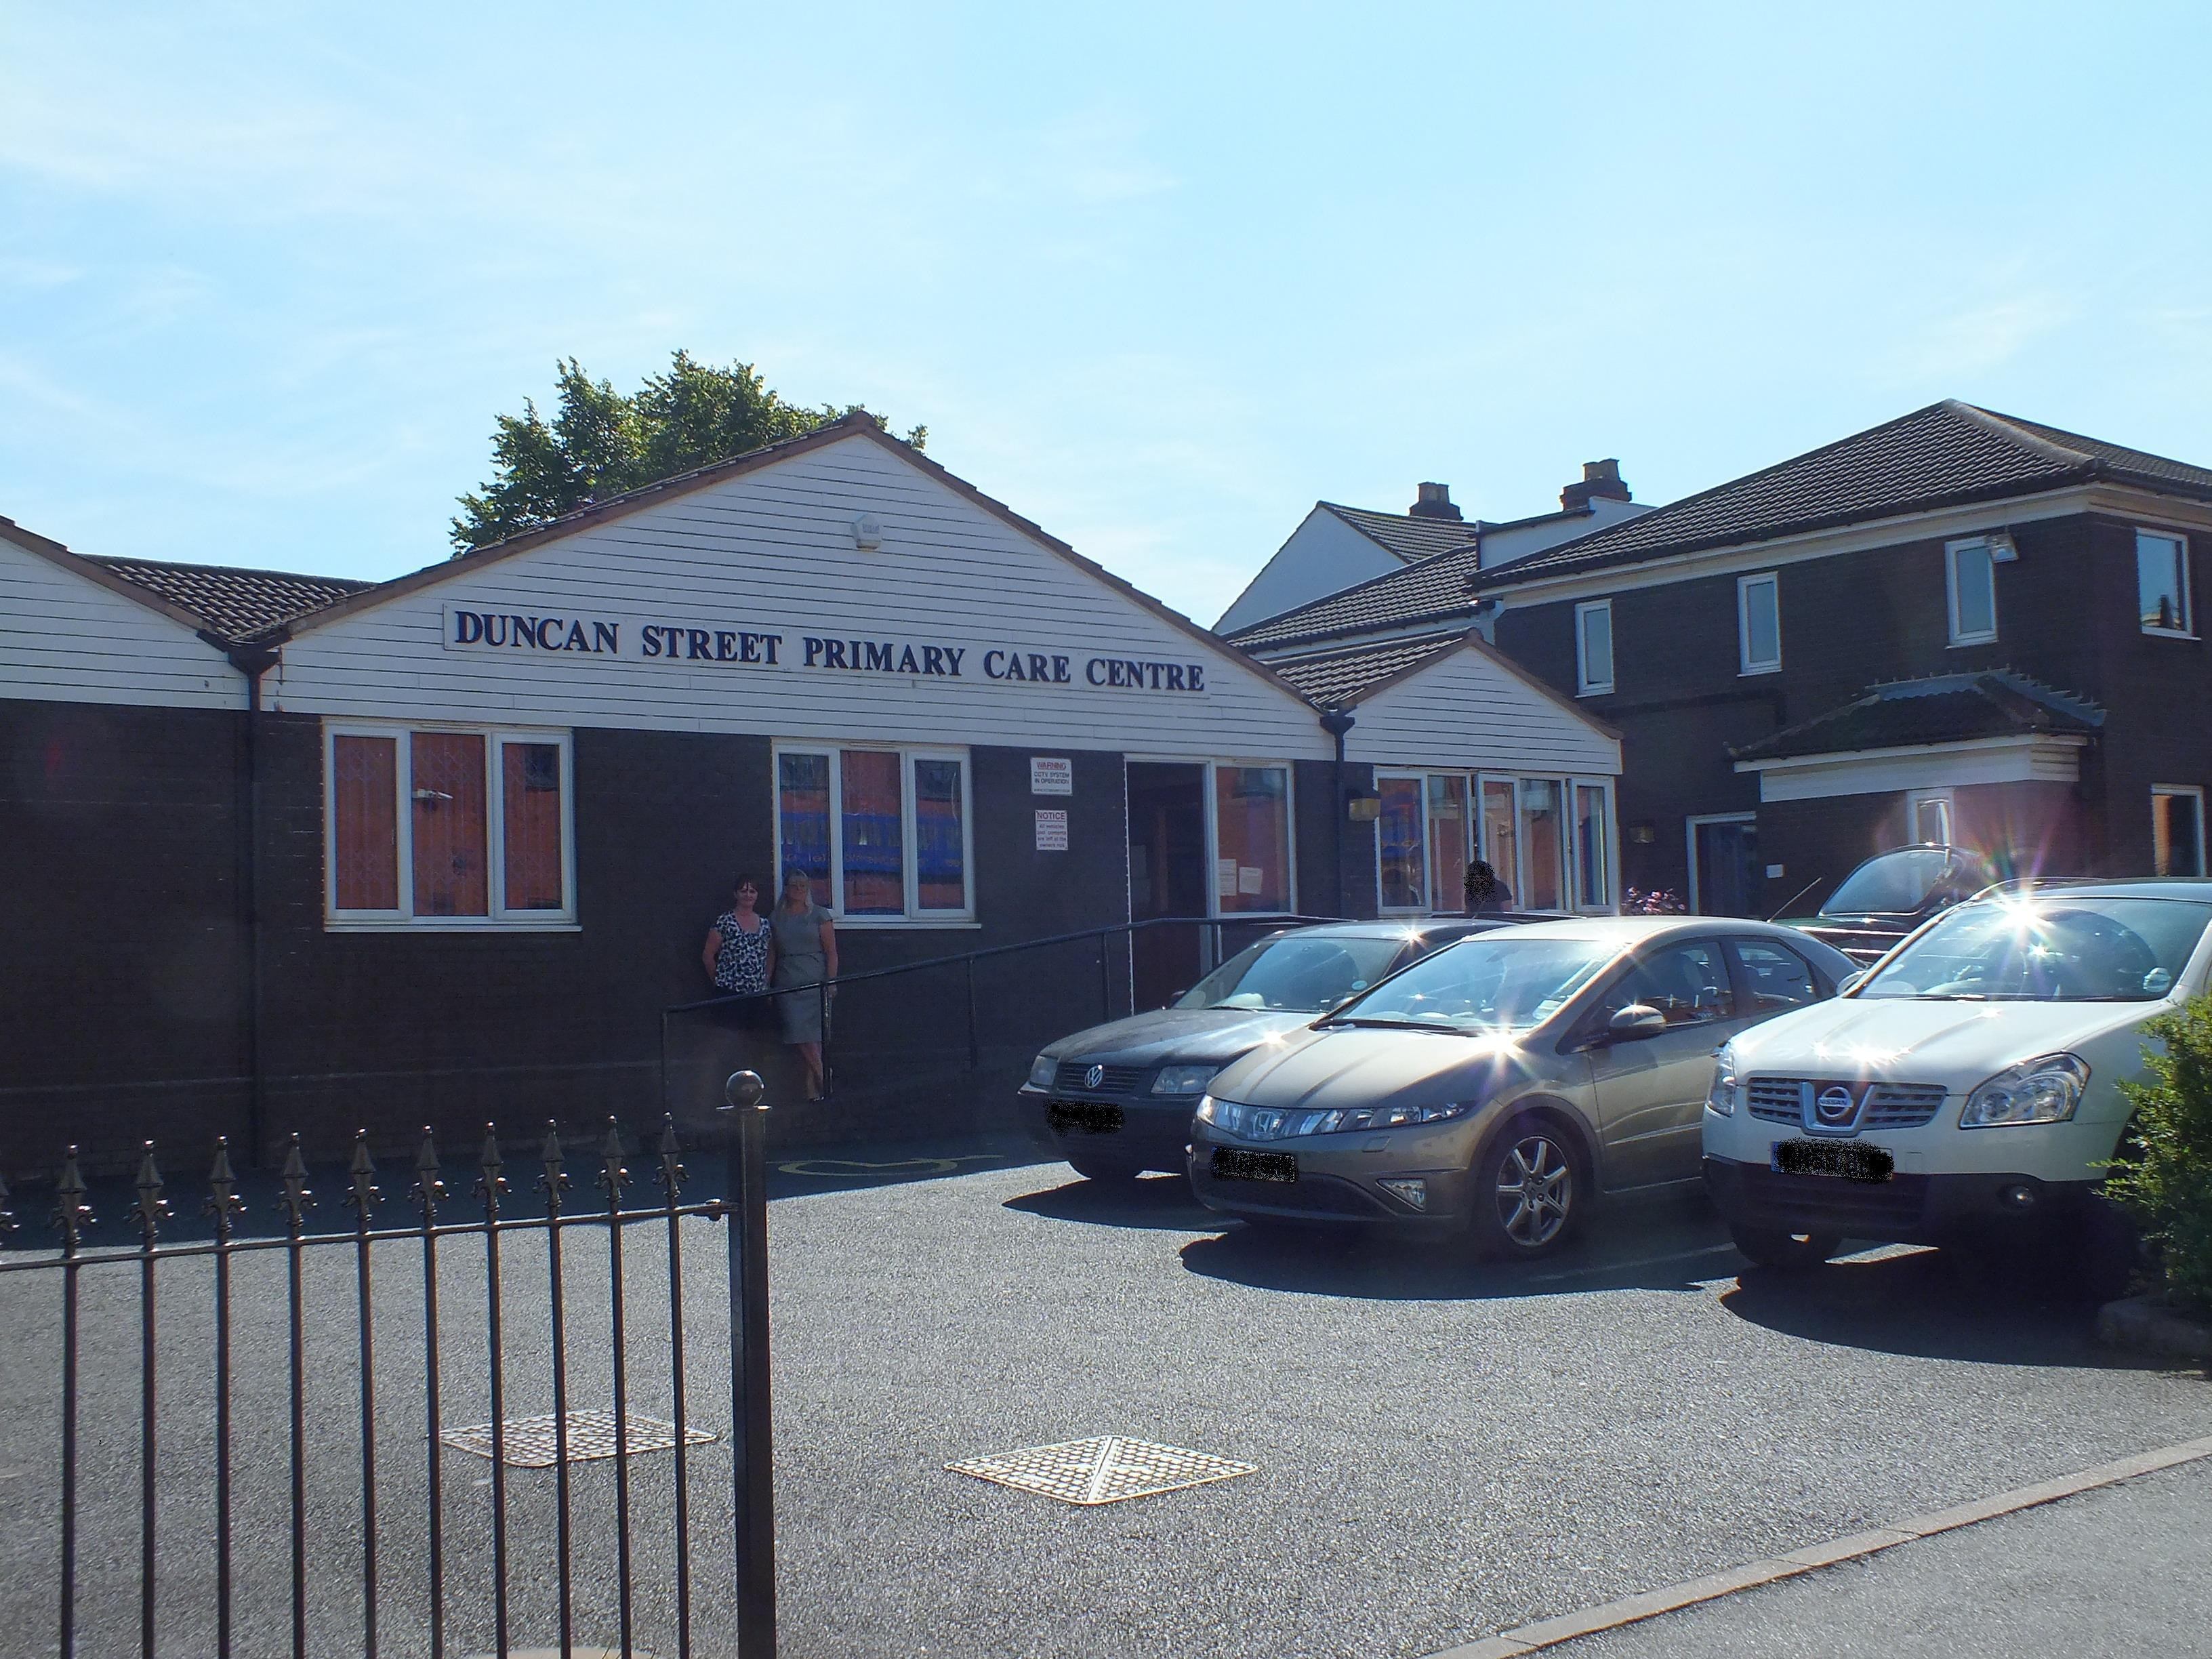

Updated: January 2025

Surgery Opening Hours

Opening Times

Monday 8.00am-6.30pm
Tuesday 8.00am-6.30pm

Wednesday 8.00am-8.00pm
Booked appointments only after 6.00pm on late night opening.

Thursday 8.00am-6.30pm
Friday 8.00am-6.30pm

Please note: Surgery doors open at 8.30am each morning and close at 6.00pm each evening, the telephone lines will be active from 8.00am – 6.00pm.

During the lunchtime period the surgery doors are closed between 1.00pm – 2.00pm each day.

When the surgery is closed, the telephone system should automatically divert calls to 111, the emergency out of hours GP service.

1

All employees and sub-contractors engaged by our practice are asked to sign a confidentiality agreement. The practice will, if required, sign a separate confidentiality agreement if the client deems it necessary. If a sub-contractor acts as a data processor for Duncan Street Primary Care Centre an appropriate contract (art 24-28) will be established for the processing of your information.
In Certain circumstances you may have the right to withdraw your consent to the processing of data. Please contact the Data Protection Officer in writing if you wish to withdraw your consent. If some circumstances we may need to store your data after your consent has been withdrawn to comply with a legislative requirement.
Some of this information will be held centrally and used for statistical purposes. Where we do this, we take strict measures to ensure that individual patients cannot be identified. Sometimes your information may be requested to be used for research purposes – the surgery will always gain your consent before releasing the information for this purpose in an identifiable format. In some circumstances you can Opt-out of the surgery sharing any of your information for research purposes

Comments, Suggestions and Complaints
In the first instance, please speak to one of the receptionists who will endeavour to offer an explanation or solution to your question immediately. If you wish to speak to someone away from the reception area, make this known to the receptionist. If you are still unhappy and do not feel your complaint has been answered or dealt with, speak to the Practice Manager, or leave a message with contact details and they will contact you. If you feel it necessary to put something in writing, please address your letter to the Practice Manager. You should receive acknowledgement of your complaint within three working days. You can contact the local Advocacy Service 01902 572399 or e-mail info@healthwatchwolverhampton.co.uk you can obtain a copy of the complaint’s procedure and comments forms from the reception desk. We continually strive to improve the services here for your benefit and we welcome all your comments – good or bad. You may email bcicb.duncanstreet@.nhs.net or contact: Time2Talk Telephone 0300 0120 281 and select Option 4
Email: bcicb.time2talk@nhs.net
Address: Time2Talk, NHS Black Country Integrated Care Board (ICB) Civic Centre, St Peter’s Square, Wolverhampton, WV1 1SH

14

Confidentiality and Information

How do we maintain the confidentiality of your records?
We are committed to protecting your privacy and will only use information collected lawfully in accordance with:
- Data Protection Act 2018
- The General Data Protection Regulations 2016
- Human Rights Act 1998
- Common Law Duty of Confidentiality
- Health and Social Care Act 2012
- NHS Codes of Confidentiality, Information Security and Records Management
- Information: To Share or Not to Share Review
Every member of staff who works for an NHS organisation has a legal obligation to keep information about you confidential.
We will only ever use or pass on information about you if others involved in your care have a genuine need for it. We will not disclose your information to any third party without your permission unless there are exceptional circumstances (i.e. life or death situations), where the law requires information to be passed on and / or in accordance with the information sharing principle following Dame Fiona Caldicott’s information sharing review (Information to share or not to share) where “The duty to share information can be as important as the duty to protect patient confidentiality.” This means that health and social care professionals should have the confidence to share information in the best interests of their patients within the framework set out by the Caldicott principles.

Our practice policy is to respect the privacy of our patients, their families and our staff and to maintain compliance with the General Data Protection Regulations (GDPR) and all UK specific Data Protection Requirements. Our policy is to ensure all personal data related to our patients will be protected.

13

Welcome

Welcome to Duncan Street Primary Care Centre. The information in this booklet should help you get the most from your Practice. Our aim is always to provide you with an excellent service. All members of the team: clinical and non-clinical staff are committed to providing this for you.

The clinical team consists of doctors, nurse practitioner and practice nurses. Other health care professionals visit the Practice to see and treat patients.

There are a large number of doctors at the surgery, including doctors training to be GPs.

There are facilities for disabled patients, including specific parking spaces, a lift and ramp access for wheelchairs. A wheelchair is available for patients who have difficulty walking from the waiting room to the consulting rooms. We welcome guide dogs anywhere in the building.

The clinical team is fully supported by a team including receptionists, administrators, secretary and a manager.

If you have any questions or concerns, please ask to speak to the Senior Receptionist or the Practice Manager.

2

Doctors and Qualifications

Dr Saumya Agarwal (M) Senior GP Partner MBBcH,MRCGP

Dr Shweta Aggarwal (F) MBBS, MRCGP

Dr Sophia Nazir (F) MMBS, MRCGP

Dr Baljinder Sangha (F) MBBS, MRCGP

Dr Reneka Farmah (F) MuDr and MRCGP

Dr Munisha Kahlan (F) MB ChB

Accountable GP for all newly registered patients and aged 75 and over. – Dr Saumya Agarwal

GP Partner – Sole Partnership - Dr Saumya Agarwal – Duncan Street Primary Care Centre, WV2 3AN

The surgery also has GP registrars and Foundation Year Two doctors. The GPRs are fully qualified doctors who are training to be GPs. The FY2 doctors are in their second year of qualification, gaining experience in general practice before specialising.
All doctors in training are always supervised, and if they are not entirely sure what care or prescription is required, they will seek advice.

3

Accessible Information Standard

If you or someone you know has a communication need or require information given in a specialist format, please ask for a form from reception to detail your communication and information preferences

Access to Medical Records

All patients are able to view their records via on-line patient Emis access, you will need to register for this service, please ask reception for details.

Practice Boundary Area

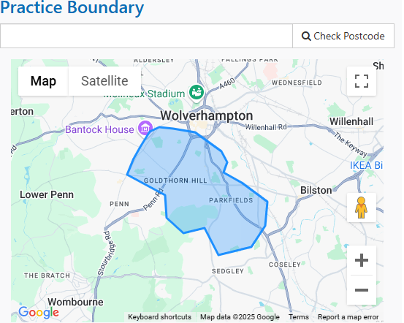

Patient Participation Group

The Practice have always valued the views of their patients and to explore ways of improving communications, enlist views about services and how these can be developed, the practice has a Patient Participation Group. The Group gives feedback on the range and quality of services and on what can be improved and they meet quarterly. If you would like to join them please contact the Practice Manager. There is a Notice Board in the waiting room for latest information.

12

Non-NHS Examinations

If you need to have a private medical, e.g. for pre-employment, HGV, taxi driving, an appointment can be arranged. Fees will be charged according to BMA guidelines. Please contact a member of the Admin team for further advice.

Rights and Responsibilities of Patients

The practice endeavours to provide an excellent service to all its patients. However, it is important for patients to understand our procedures to enable the surgery to run smoothly. While this surgery will do its best to meet the needs of patients, we will not accept violent or aggressive behaviour or verbal abuse towards our staff. The surgery reserves the right to prosecute offenders.

How to Register

Registering as a new patient

If you wish to register at the practice, you must attend the surgery in person with Photo ID and proof of current address, if children are registering they must also attend.
Waiting list for registrations at present is up to six weeks. If form is not completed in full there is likely to be a further delay.
- A registration form (PRF1) can be collected from the reception
- Registering online – please click on the below link Register with a GP surgery
- All patients must attend personally to hand in completed forms.
- We only except completed PRF1 forms and ID's between 3.00pm - 5.00pm Monday to Friday.
- If you have a current NHS number please make sure you enter this on the form. You can find your NHS number on this link, https://www.nhs.uk/nhs-services/online-services/find-nhs-number/.
- Your details will then be entered onto our system and once NHS England have approved your details, the practice will send you a text for you to book a New Patient Check appointment.
- You MUST attend this appointment to complete your registration.
- If you do not book or attend your New Patient Check appointment you may be unable to see a Doctor when you need to.
- IF YOU REGISTER ELSEWHERE BEFORE RECEIVING A TEXT FROM US PLEASE LET US KNOW SO WE CAN CANCEL YOUR REGISTRATION.

ZERO TOLERANCE

We strongly support the NHS policy on zero tolerance. Anyone attending the surgery who abuses the GPs, staff or other patients be it verbally, physically or in any threatening manner whatsoever, will risk removal from the practice list. In extreme cases we may summon the police to remove offenders from the practice premises.

11

The Practice Manager

The Practice Manager is responsible for the overall management of the Practice. They will be pleased to discuss any non-medical problems with you and welcomes any suggestions you may have for improving the service provided.

The Reception Team

The receptionists are trained to help and guide you. All information they receive will be treated in the strictest confidence. Please do not blame the receptionist if you are unhappy with the service you receive. If there is a problem, please ask to speak to the Reception Manager or the Practice Manager.

Administration staff/Secretary

The Administration Team are responsible for arranging various clinics and registration of new patients and any information or documentation required for outside agencies.

The secretary provides administration support for the Practice dealing with all GP referrals.

4

The Nursing Team

They see patients with minor injuries, minor illnesses, run child vaccination clinics, provide cervical smears, contraceptive injections and offer reviews for patients with long term conditions such as asthma, COPD and diabetes.

Nursing Team
Nurse Practitioner:
Ros Rawlinson - RGN DIPDN Diabetic Diploma, BSc (Hons) Healthcare Practitioner

Practice Nurses:

Lisa Bromley
Registered nurse Level 2 1989
Registered Nurse level 1 2002

Kirsty Darley
Reg Nurse / Independent Supplementary Prescriber, Diploma in Diabetes, Asthma and COPD

5

Equal Access Measures

There are ramps to the main entrance to the surgery, enabling access for wheelchair users and those with poor mobility. There are disabled parking spaces.

There is a lift suitable for wheelchair users installed in the surgery for those with appointments upstairs. If you have any difficulty with stairs, please inform the clinician calling you and the lift will be used or if you require any assistance please ask at the reception desk. The surgery has a wheelchair available for patients to use if required.

We have a portable hearing loop in the practice if you wish to use it. Please ask a receptionist.

10

Access to a GP or Healthcare Professional

Routine appointments can be booked in advance. Appointments are
If you ring between 8.30am and 1pm you can book an appointment for the same day. After 1.00pm appointments may not be available for the same day. We have emergency appointments allocated by the Doctor on call every day.

Home Visits

If you feel you require a visit (for housebound patients only), you need to telephone before 10.30am and give details of your illness. A doctor may call to you back to assess the urgency of your request.

Chronic disease checks for the housebound can be arranged. Patients are contacted by the surgery to arrange reviews and if you are housebound, please contact the surgery so a check-up can be arranged.

Carer

Our carer lead is Sister Darley. If you look after someone or someone looks after you, please complete a carer form. The practice also has a Carer Notice Board which holds various helpful information.

9

Out of Hours Arrangements

If you have a medical problem after 6.30pm in the evening and before 8.00am in the morning which cannot wait until the surgery is open, there is an out of hours GP emergency service. This can be accessed by calling the surgery number, where you will be diverted to the appropriate service. Otherwise the out of hours services can be contacted by calling 111. Please only use the 999 service for medical emergencies. During all other hours use the practice telephone number shown on the front cover of this leaflet.

We take part in providing extended access for patients across out Primary Care Home network. We have Information Governance in place to enable shared IT via our systems. These appointments can be accessed by contacting the reception team who can book these appointments for routine and urgent appointments.

BC ICB are responsible for commissioning out of hours.

Other Sources of Advice

NHS 111 Number
111 are available at all times for medical advice. Please call 111

Community Pharmacies
The surgery takes part in a minor ailments scheme. If you know what is wrong, e.g. headline, but do not pay for prescriptions, you can go to the pharmacy and ask for a minor ailment form.

Walk in Centres
There are two Walk-in Centres in Wolverhampton. Wolverhampton Walk-in Centre at the Phoenix Centre is led by nurse practitioners, who can prescribe, or you can attend the Urgent Care Services at New Cross Hospital. Patients do not have to register at these services in order to be seen.

6

Interpreter Services

Each weekday an interpreter is present at the surgery for non-English speaking patients who speak Asian languages, including Punjabi.

For other languages, including sign language, interpreters can be booked, giving as much notice as possible. The surgery routinely uses Language Line telephone interpreting.

If you are attending on appointment and may require an interpreter, please check with the surgery beforehand, so this can be arranged.

Ordering Repeat Prescriptions
1. E-mail: bcicb.duncanstreet@nhs.net (incoming only)

- Hand delivered. There is a post box in the entrance to avoid you
having to queue at the reception desk.

- Register for online access to your records and request prescription through this system. (ask reception about registering for online access).

- By post, enclosing a stamped addressed envelope if you wish us
to post your prescription back – otherwise you will need to collect it for the practice.

- Ask your nominated pharmacy to order on your behalf

Please use the other half of your prescription to request items. If you do not have this, complete one of the prescription request forms which are available from reception. You need to allow 72hours for your prescription to be prepared. Prescriptions can be collected during normal surgery hours.

7
We now participate in (EPS) Electronic Prescription Service. Please visit the EPS website http://systems.hscic.gov.uk/eps or you can speak to the pharmacy for further information.

Certain medications cannot ordinarily be ordered on repeat as reviews are needed. Please enquire at reception or during a consultation to find out whether a medication can be ordered.

Test Results

In the interests of confidentiality your results will only be given to you. You will be asked for information to identify yourself. Parents or guardians of a child under the age of 16 are able to telephone for results. Please phone for test results after 12.00pm if possible as the surgery phone lines are very busy in the morning.

The surgery has a height, weight and BP machine for you to use, the readings are automatically recorded in your medical notes.

8

